Revise SAS Code. Not Good.

Part I:

Data with Quarter Dummies and Structural Dummies:

|  |
| --- |
| SAS CODE:  **PROC** **IMPORT** OUT= WORK.bijesh  DATAFILE= "C:\Users\bmishra\Dropbox\Ph.D. Courseworks\Semest  er II, Spring 2019\Econometric Methods\Homeworks\Homework 3\HW3-DATA1_SEAS.tx  t"  DBMS=TAB REPLACE;  GETNAMES=YES;  DATAROW=**2**;  **RUN**;  **proc** **print**;  **run**; |

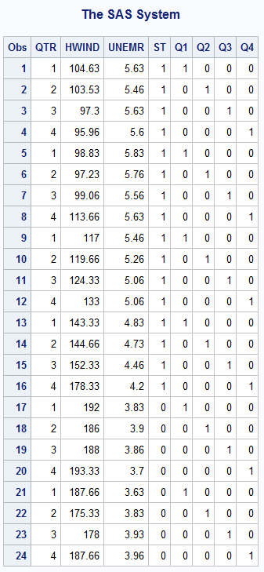

1.

|  |
| --- |
| SAS Code:  **proc** **reg** data = bijesh;  model hwind = unemr q1 q2 q3;  **run**; |

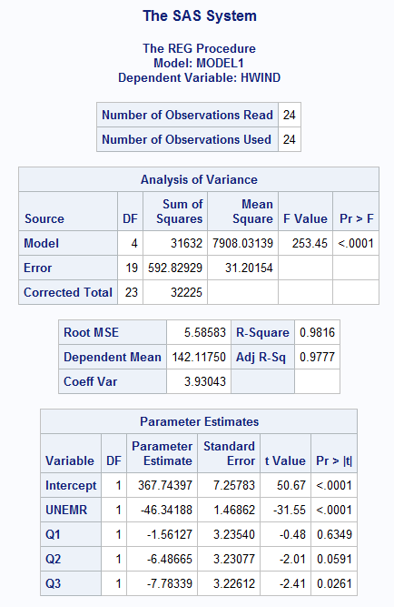

hwind = 367.74397 -46.34188 unmer -1.56127q1 – 6.48665q2 - 7.78339q3 + e.

When, help wanted index is rising, there are a relatively large amount of position needing to be filled and can be interpreted as shortage of workers. Since fourth quarter is typically s period of increased retail activity, the labor shortage should be high and the help wanted index value should be high compared to other seasons. i.e. Help wanted index should have negative sign in comparison to fourth quarter and three seasons retain the predicted sign.

Looking at p-values, third quarter dummy (q3) is significantly different from zero but other are not at 5% level of significance but intercept and UNEMR are.

2.

|  |
| --- |
| SAS Code:  **proc** **reg** data = bijesh;  model hwind = unemr q1 q2 q3;  **run**;  test q1 = q2 = q3 = **0**;  **run**; |

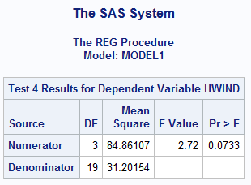

Looking at the p-value (0.0733) of F-test, the dummy variables are not significantly different than zero at 5% significance level. So, they should not be included in the equation.

3.

If the above model was estimated without seasonal dummy variables, the estimate would not answer the question whether different season affect help wanted index. Also, we would not be able to answer in which direction each season affect in the help wanted index. The seasonal dummy variable is omitted from the analysis.

4.

|  |
| --- |
| SAS Code:  I separated data into two files: (HW3-DATA1_SEAS1) one with seaonal dummy = 1 and (HW3-DATA1_SEAS0) another with seasonal dummy = 0  Run Regression with variables which has seasonal dummy =1;  **PROC** **IMPORT** OUT= WORK.bijesh  DATAFILE= "C:\Users\bmishra\Dropbox\Ph.D. Courseworks\Semest  er II, Spring 2019\Econometric Methods\Homeworks\Homework 3\HW3-DATA1_SEAS1.tx  t"  DBMS=TAB REPLACE;  GETNAMES=YES;  DATAROW=**2**;  **RUN**;  **proc** **reg** data = bijesh;  model hwind = unemr q1 q2 q3;  **run**;  Run Regression with variables which has seasonal dummy =0;  **PROC** **IMPORT** OUT= WORK.bijesh  DATAFILE= "C:\Users\bmishra\Dropbox\Ph.D. Courseworks\Semest  er II, Spring 2019\Econometric Methods\Homeworks\Homework 3\HW3-DATA1_SEAS0.tx  t"  DBMS=TAB REPLACE;  GETNAMES=YES;  DATAROW=**2**;  **RUN**;  **proc** **reg** data = bijesh;  model hwind = unemr q1 q2 q3;  **run**;  Run Full Model with complete Data:  **PROC** **IMPORT** OUT= WORK.bijesh  DATAFILE= "C:\Users\bmishra\Dropbox\Ph.D. Courseworks\Semest  er II, Spring 2019\Econometric Methods\Homeworks\Homework 3\HW3-DATA1_SEAS.tx  t"  DBMS=TAB REPLACE;  GETNAMES=YES;  DATAROW=**2**;  **RUN**;  **proc** **print**;  **run**;  **proc** **reg** data = bijesh;  model hwind = unemr q1 q2 q3 st;  **run**; |

I would expect negative sign as first 16 observations (low value) has 1 and last 8 observations (high value) has 0 for structural change dummy.

Null Hypothesis: There is no structural Change. i.e. beta coefficients for UNEMR, Q1, Q2 and Q3 when seasonal dummy =1 and that when seasonal dummy = 0 are equal.

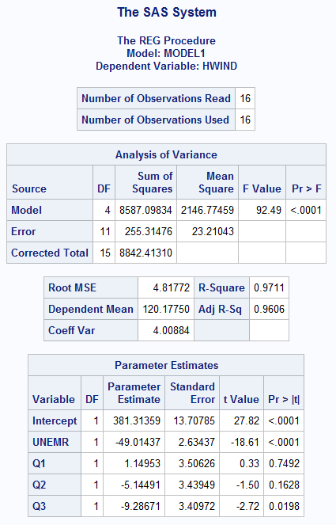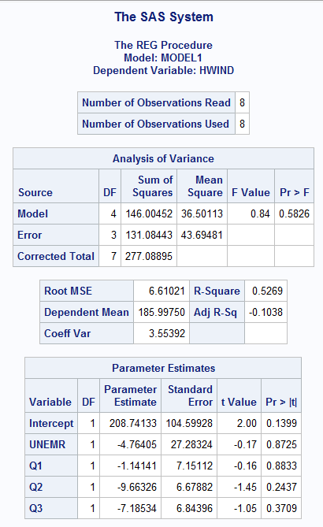

Figure Regression model with seasonal dummy = 1 (left) and with seasonal dummy = 0 (right)

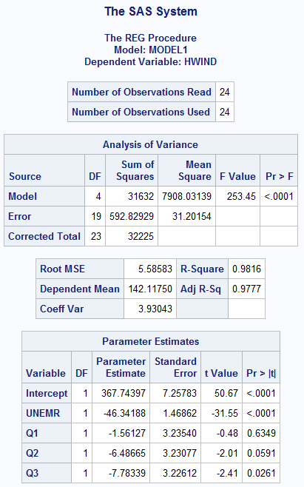

Figure: Full model

SSEU = 255.31476+131.08443 = 386.39919

SSER = 592.82929

Numerator df = 5

Denominator df = 24 – 10 = 14.

Fcalc = ((592.82929-386.39919)/5)/(386.39919/14) = 1.495873

Fcric (Prob = 0.05, N df = 5, D df = 14) = 2.96

Since, F-calc > F cric, we fail to reject null hypothesis. i.e. indicates no structural break.

5.

|  |
| --- |
| SAS Code:  **proc** **reg** data = bijesh;  model hwind = unemr q1 q2 q3 st;  **run**;  test st = **0**;  **run**; |

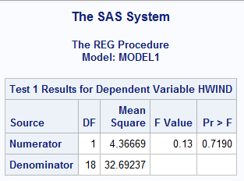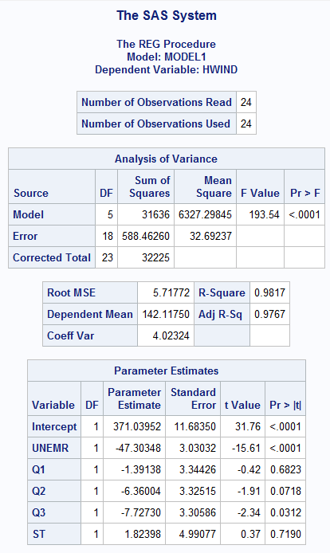

Ho: βst = 0 and Ha: βst ≠ 0,

The test with alternative hypothesis that the coefficient of the structural change dummy is zero is also not statistically significant as P-value is greater than 0.05. So we fail to reject null hypothesis.

6. Null Hypothesis: There is no structural break.

Alternative Hypothesis: There is seasonal break.

|  |
| --- |
| SAS Code:  Chow test without seasonal dummy variables:  **proc** **autoreg** data = bijesh;  model hwind = unemr/chow = (**16**);  **run**; |
| SAS Code:  Chow test with seasonal dummy variables:  **proc** **autoreg** data = bijesh;  model hwind = unemr q1 q2 q3/chow = (**16**);  **run**; |

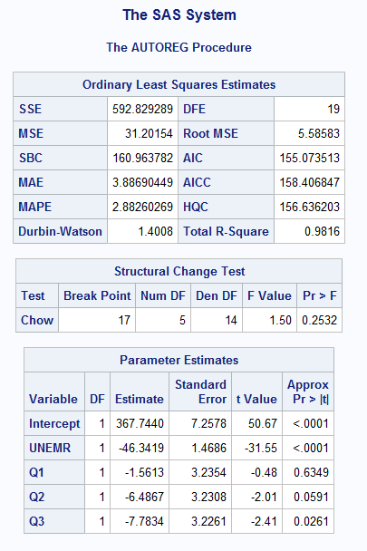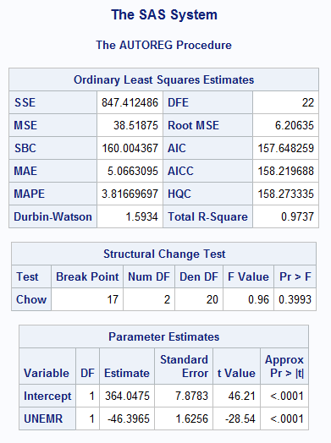

We fail to reject null hypothesis in both models indicating no structural break. The seasonal effect is not significant in the chow test for both models—with and without seasonal dummies. This result is also consistent with the model when seasonal dummy was included in the model instead of doing chow test. Both intercept and unemr are significant in both models. Chow test with seasonal variable is similar to the analysis on question 4.

Part II:

|  |
| --- |
| **PROC** **IMPORT** OUT= WORK.bm  DATAFILE= "C:\Users\bmishra\Dropbox\Ph.D. Courseworks\Semest  er II, Spring 2019\Econometric Methods\Homeworks\Homework 3\HW3-DATA2.xl  s"  DBMS=EXCEL REPLACE;  RANGE="'FOOD COST$'";  GETNAMES=YES;  MIXED=NO;  SCANTEXT=YES;  USEDATE=YES;  SCANTIME=YES;  **RUN**;  **data** bm; set bm;  y = y;  x = x;  sqx = x\*\***2**;  cubx = X\*\***3**;  **run**; |

Total cost function:

Y = 134.65598 + 57.9702 X1 – 11.02894 X12 + 1.143 X13 + e

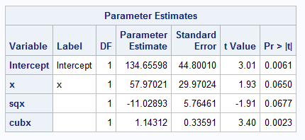

1. Marginal cost function is the first derivative of total cost function.

Y = 57.9702 – 2* 11.02894 X1 + 3*1.143 X12 + e

Y_marginal = 57.9702 – 22.05788 X1 + 3.429 X12 + e

2. Average Cost Function: total cost divided by total unit of production i.e. X1.

Y_average = 134.65598/ X1 + 57.9702 – 11.02894 X1 + 1.143 X12 + e

3. CI = Parameter Estimates (β) ± t-cric (df)* standard error.

t-cric(24) = 2.064 at alpha = 0.05/2.

CI for β2 = 57.97021 ± 2.064 * 29.97024 = [-3.885325, 119.8257]

CI for β3 = -11.02893 ± 2.064 * 5.76461 = [-22.92651, 0.8686457]

CI for β4 = 1.143118 ± 2.064 * 0.33591 = [0.44983, 1.836405]

4.

|  |
| --- |
| Ramsey RESET Test:  SAS Code:  **proc** **autoreg** data = bm;  model y = x sqx/reset;  **run**; |

Null hypothesis: the model does not have omitted variable.

Alternative hypothesis: The model has omitted variable.

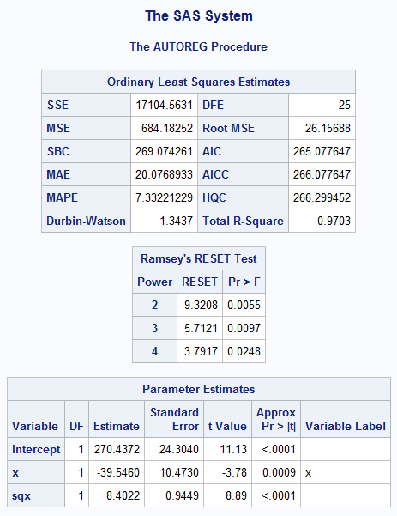

The P-value of RESET test for are not significantly different than zero as it is greater than 0.05. So we reject the null hypothesis which means the test is able to detect misspecification in the model. So, linear function would not be a good fit.

5.

|  |
| --- |
| **proc** **autoreg** data = bm;  model y = x sqx cubx/reset;  **run**; |

Null hypothesis: the model does not have omitted variable.

Alternative hypothesis: The model has omitted variable.

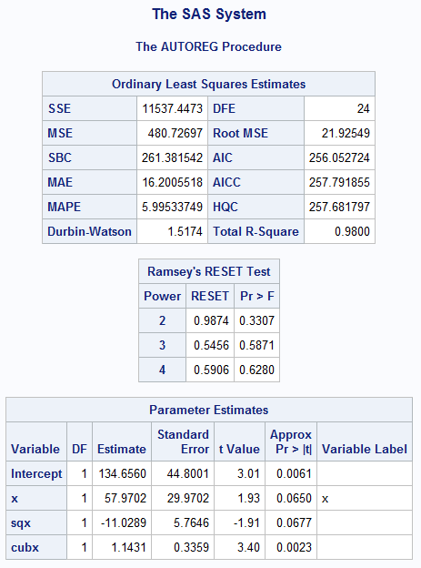

The P-value of RESET test are not significantly different than zero as they are greater than 0.05. So we fail to reject the null hypothesis which means the test is not able to detect any misspecification. Shows, quadratic function is a better fit.

6.

|  |
| --- |
| **proc** **reg** data = bm;  model y = x sqx cubx;  **run**;  test x = sqx = cubx = **0**;  **run**; |

Average cost function is not linear.

Ho: βx = βsqx = βcubx = 0

Ha: At least one of them is different.

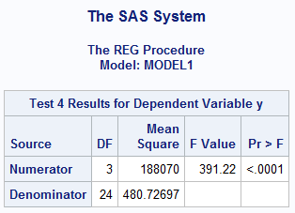

We reject null hypothesis. So, average cost is non-linear.

7: Original Cubic Cost Function and Log-log function outputs.

|  |
| --- |
| **data** bm; set bm;  y = y;  x = x;  lny = log(y);  lnx = log(x);  sqlnx = lnx\*\***2**;  **run**;  **proc** **autoreg** data = bm;  model y = x sqx cubx/reset;  **run**;  **proc** **autoreg** data = bm;  model lny = lnx sqlnx/reset;  **run**; |

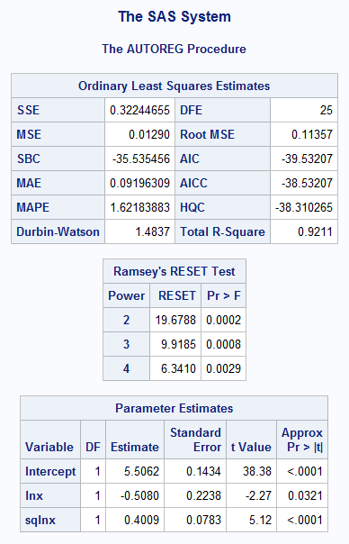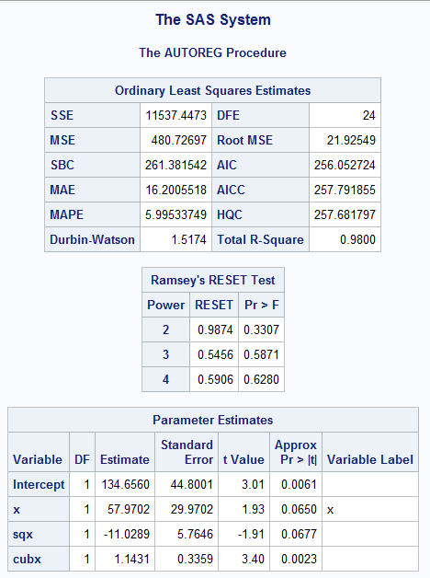

In the original cubic function, the RESET test did not detect the omitted variable as the P-value is greater than 0.05. However, in the log-log model, the RESET test detect model misspecification as the P-value is less than 0.05 and there is room for improvement. So, I prefer original cubic function instead of log-log model.

|  |
| --- |
| SAS Code Compilation:  HW3-DATA1:  **PROC** **IMPORT** OUT= WORK.bijesh  DATAFILE= "C:\Users\bmishra\Dropbox\Ph.D. Courseworks\Semest  er II, Spring 2019\Econometric Methods\Homeworks\Homework 3\HW3-DATA1_SEAS0.tx  t"  DBMS=TAB REPLACE;  GETNAMES=YES;  DATAROW=**2**;  **RUN**;  **proc** **print**;  **run**;  **proc** **reg** data = bijesh;  model hwind = unemr q1 q2 q3;  **run**;  test q1 = q2 = q3 = **0**;  **run**;  **PROC** **IMPORT** OUT= WORK.bijesh  DATAFILE= "C:\Users\bmishra\Dropbox\Ph.D. Courseworks\Semest  er II, Spring 2019\Econometric Methods\Homeworks\Homework 3\HW3-DATA1_SEAS1.tx  t"  DBMS=TAB REPLACE;  GETNAMES=YES;  DATAROW=**2**;  **RUN**;  **proc** **print**;  **run**;  **proc** **reg** data = bijesh;  model hwind = unemr q1 q2 q3;  **run**;  test q1 = q2 = q3 = **0**;  **run**;  **PROC** **IMPORT** OUT= WORK.bijesh  DATAFILE= "C:\Users\bmishra\Dropbox\Ph.D. Courseworks\Semest  er II, Spring 2019\Econometric Methods\Homeworks\Homework 3\HW3-DATA1_SEAS.tx  t"  DBMS=TAB REPLACE;  GETNAMES=YES;  DATAROW=**2**;  **RUN**;  **proc** **print**;  **run**;  **proc** **reg** data = bijesh;  model hwind = unemr q1 q2 q3 st;  **run**;  test st = **0**;  **run**;  **proc** **autoreg** data = bijesh;  model hwind = unemr q1 q2 q3/chow = (**17**);  **run**;  **proc** **autoreg** data = bijesh;  model hwind = unemr/chow = (**17**);  **run**;  **proc** **print**;  **run**;  SAS Code:  PART II:  **PROC** **IMPORT** OUT= WORK.bm  DATAFILE= "C:\Users\bmishra\Dropbox\Ph.D. Courseworks\Semest  er II, Spring 2019\Econometric Methods\Homeworks\Homework 3\HW3-DATA2.xl  s"  DBMS=EXCEL REPLACE;  RANGE="'FOOD COST$'";  GETNAMES=YES;  MIXED=NO;  SCANTEXT=YES;  USEDATE=YES;  SCANTIME=YES;  **RUN**;  **proc** **print**;  **run**;  **data** bm; set bm;  y = y;  x = x;  sqx = x\*\***2**;  cubx = X\*\***3**;  **run**;  **proc** **print**;  **run**;  **proc** **reg** data = bm;  model y = x sqx cubx;  **run**;  test x = **0**;  test sqx = **0**;  test cubx = **0**;  test x = sqx = cubx = **0**;  **run**;  **proc** **autoreg** data = bm;  model y = x sqx/reset;  **run**;  **proc** **autoreg** data = bm;  model y = x sqx cubx/reset;  **run**;  **data** bm; set bm;  y = y;  x = x;  lny = log(y);  lnx = log(x);  sqlnx = lnx\*\***2**;  **run**;  **proc** **autoreg** data = bm;  model y = x sqx cubx/reset;  **run**;  **proc** **autoreg** data = bm;  model lny = lnx sqlnx/reset;  **run**; |